Toman Bike Share Project.

Email Requests

Request for Development of Toman Bike Share Dashboard

Dear Data Analyst,

We need your expertise to develop a dashboard for "Toman Bike Share" that displays our key performance metrics for informed decision-making.

Requirements:

Hourly Revenue Analysis

Profit and Revenue Trends:

Seasonal Revenue

Rider Demographics

Design and Aesthetics: Use our company colours and ensure the dashboard is easy to navigate.

Data Source: Access to our databases will be provided. If no database, please create one

Deadline: We need a preliminary version ASAP.

Please provide an estimated timeline for completion and recommendation on raising prices next year

Best regards,

**Power BI Process**

1. Create Header

* Insert – Shapes – rectangle. Drag to fit. Change color (Format pane – style – select color)

1. Create background panels

* Insert Card. Use any value to activate. In format pane, OFF callout value and label. ON accent bar, make color similar, ON border and shadow, OFF background from effects.
* Drag and adjust.
* Copy and replace twice, then adjust.
* Copy and paste again and on this, turn on images. Add image by URL or from the computer directly. OFF border, shadow, accent bar and glow from visuals.

1. Adding data

* Select Matrix visual, use `hr` as rows and `revenue` as value (Average) then rename to Revenue as heading for values. Add `weekday` to column. Remove subtotals, adjust fonts then place visual.
* Remove table design: `layout and style presets`, select None.
* To get only working hours, select the `hr` and confirm the format is whole number. Go to filters, select advanced filtering. Choose Is greater than `7` AND Is less than 21. APPLY FILTER. OFF vertical and horizontal grid lines.
* Select `Revenue` from data panel, click $ in the top bar and choose 0 decimal places.
* Select text box to add text on visual.
* Select the Line and clustered column chart. Drag dteday to X axis and riders to Column. Click the double arrow on the visual to drill down to months. Remove Quarter from x axis.
* Select column in visualization pane and do conditional formatting then OK.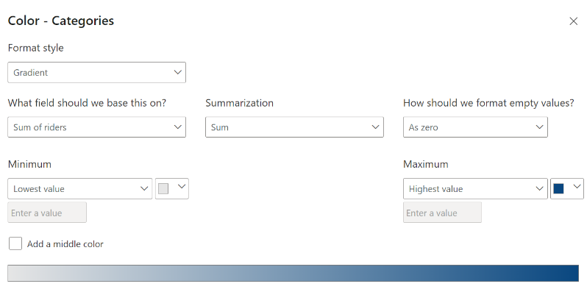
* Drag Profit and Revenue to line-y axis, then change to average.
* Visual – Secondary Y axis - ON Align zeros.
* Visual – Line – ON markers
* Change name of Column Y -axis to Riders
* OFF X- axis title, change chart title to KPI Over Time then edit fonts.
* Chose clustered bar chart – Drag Seasons to Y-axis, Revenue (Sum) to X-axis.
* Visualization: ON Data labels, change color of bars and edit fonts. Change `type` of Y axis to categorical.
* Change chart title to Revenue by season.
* Select `rider type` and then `rider` from data panel, then click donut chart.
* Visualisation: OFF Legend, change color, rename chart.
* Insert shape- line to separate the two visuals. Color change line and adjust to fit. Change the line color for each as you see fit: Line – set series to “average of revenue” – change color
* Duplicate the line chart and convert to Card. Change from Average to Sum for revenue and profit in data.
* Delete Riders from the card data. Change the layout to single column. Change background color and increase transparency. ON Glow and resize the card. Rename to Revenue and Profit respectively.

1. Create Header

* Select Card, Drag in Riders data and Profit margin (New measure)
* Profit margin = (Sum of Revenue – Sum of Profit ) / Sum of Profit
* Profit Margin = (SUM('Bike Data'[revenue])-SUM('Bike Data'[profit]))/SUM('Bike Data'[profit])
* To add images to the card, go to [www.flaticon.com](http://www.flaticon.com)
* Cards- OFF background, OFF border, Effects- OFF background
* Padding-adjust size
* Edit fonts of callout value and heading. Rename to Riders and Profit margin.

1. Create title and logo

* Insert circle shape, adjust and place where logo would be. Change color to white, ON border, increase width of border, change border color to blue.
* Download bike image to create logo. Add name of shop in new text box, color, OFF background.

1. Add filter

* Add slicer, Add Yr data, OFF background, ON visual border.
* Transform data – Add column – Conditional column - 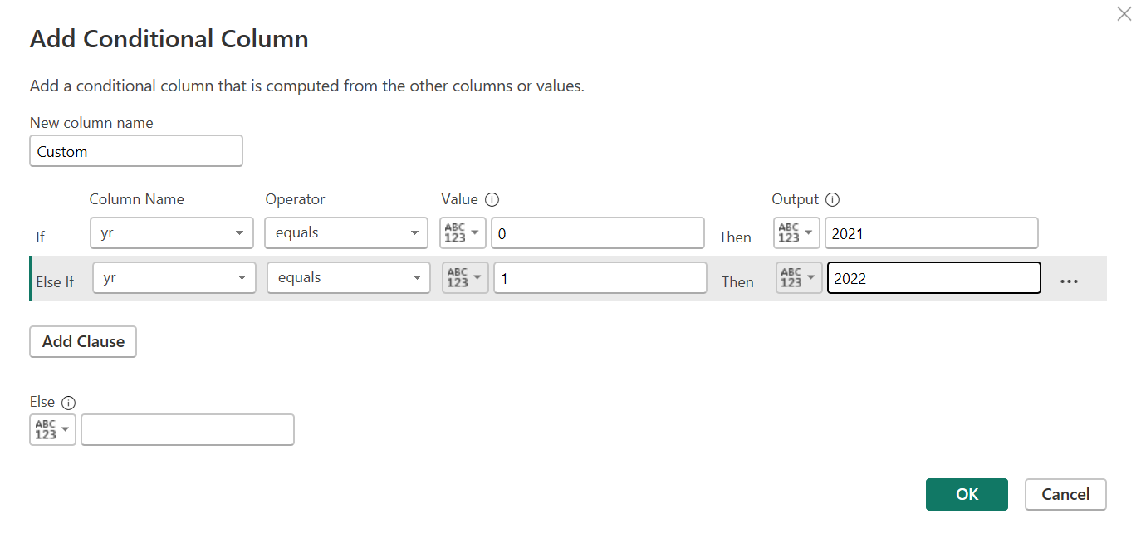
* Rename column to Years. Close & Apply

1. To evaluate if we can raise the prices for the upcoming year

* Insert Matrix, Add Years, Sum Riders, Sum Revenue, Sum Profit, Avg Price.
* It’s obvious that by a change in price by $1, there was an increase in riders, revenue and profit.
* Calculate change in price % = (New price - old price)/ Old price
* (4.99-3.99)/3.99 = 0.25 = 25% price increase
* Calculate demand of riders = (2049576 – 1243103)/ 1243103

= 0.64 = 64% increase in demand.

* Assuming metrics was linear, we can assume that if we increase the price the demand would also increase. To be sure, we can calculate price elasticity. Positive value means the users would tolerate an increase while negative values mean they won’t.
* Price elasticity = Increase in demand / Increase in pricing

64/25 = 2.56% This means demand would increase by 2.56%

* Add recommendation.